

Evaluate and Communicate business requirements – assessment 1

Jorge Trujillo - 18574



November 24, 2023

Wells international college

|  |  |  |  |
| --- | --- | --- | --- |
| Name of Student | Jorge Eduardo Trujillo Paez | ID | 18574 |

**Assessment – Research and Questioning**

Contents

Instructions: 1

Business Scenario 1

Task 1: Determine support areas 2

Task 2: Identify stakeholders 2

Task 3: Develop support procedures 2

Task 4: Assign Support Personnel 2

Task 5: Short Answer Questions 3

Task 6: Multiple Choice Questions 3

Search Index 8

#### View My Web Support:

<https://wellsjohn220.github.io/ecbr/>

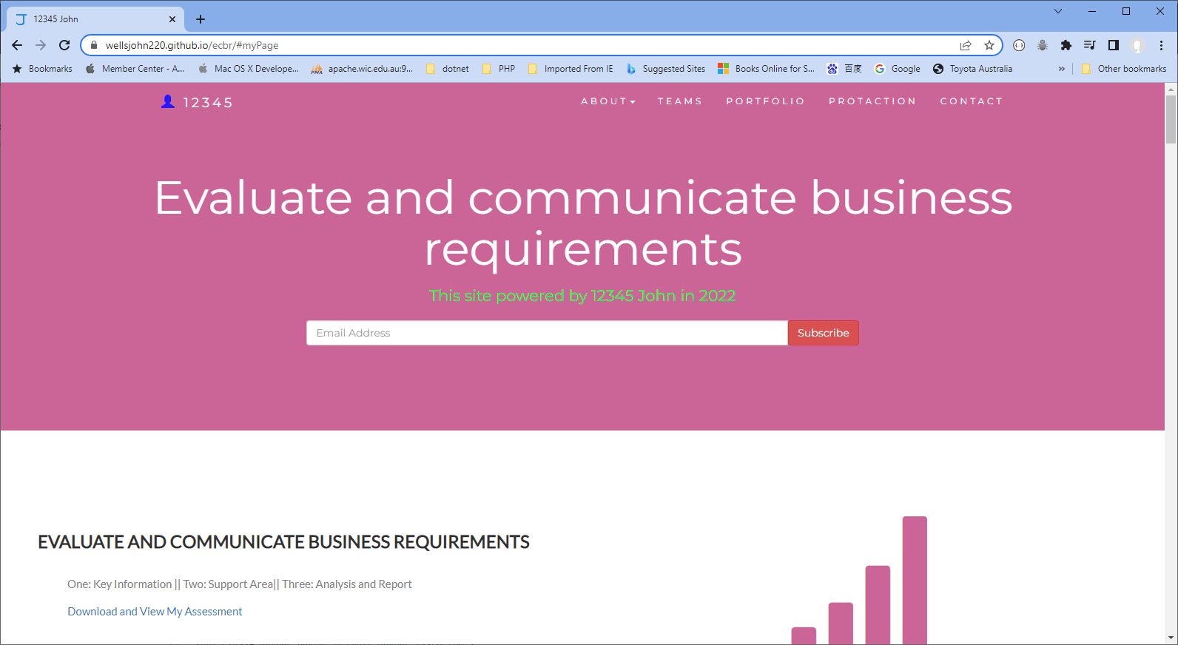

#### or

<https://wellsjohn220.wixsite.com/evaluate>

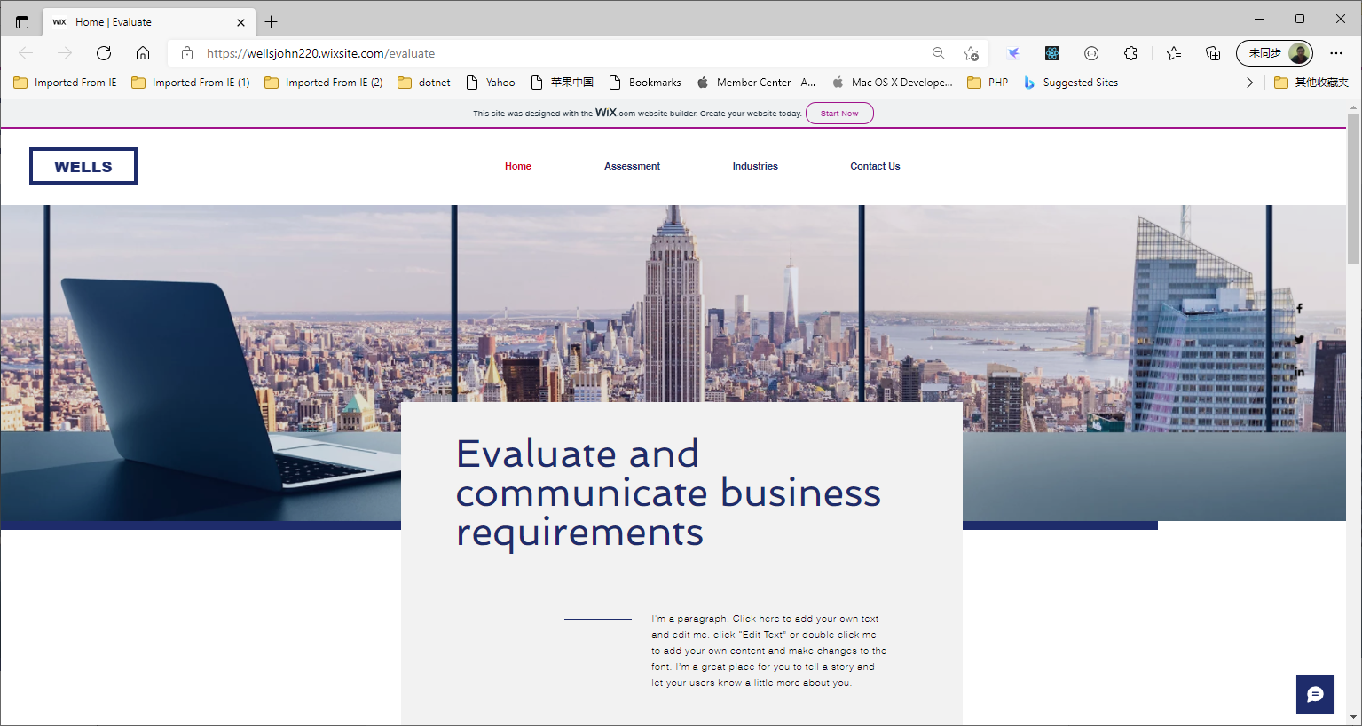

#### Instructions:

This assessment is to be completed individually. In this assessment you will be working through a number of written tasks based on case scenarios or research that relate directly to each element of competency for this cluster. Outlined below is information on how each of the tasks relates the element of competency covered.

Learn how to make Google Form: <https://www.youtube.com/watch?v=BtoOHhA3aPQ&t=4s>

Your tasks:

#### Business Scenario

D&K Books Pty Ltd is a bookstore owned by Mr. Dean Kerr. The business occupies two levels of an office building connected by escalators and lifts. D&K Books employs approximately six sales staff, one operation manager, two administrative officers, a bookkeeper and a marketing manager. They have an Ethernet network consisting of ten PCs (Intel I3 Desktop cloned), two switches, a router and three printers. They use the QuickBooks software to manage their entire business, including sales, inventory, ordering, accounts receivable, accounts payable, payroll and employee management. They also have two EFTPOS terminals one on each floor.

D&K Books has a Linux server that stores all of the data including the QuickBooks database. The server is backed up to tape regularly. They also have a website (hosted on an Australian ISP’s server, dynamic and static pages using asp.net) on which customers can browse the product catalogue and view current specials. They also lease a telephone system from Live Telecoms. The PABX (phone system) consists of a main switchboard and five remote phones with three incoming lines and a message-on-hold queue system.

Good network system, you need setup at least:

#### http://imapwebsolutions.com/wp-content/uploads/2014/07/linux-dedicated-server.pngTask 1: Determine support areas

Identify information technology (HW and SW) and list the technology in use in D&K Books and consider the following:

* What sort of support does the technology require?
* Who is likely to provide this support?
* Does the support arrangement already exist?

Present your answer in a table such as the one below:

|  |  |  |  |  |
| --- | --- | --- | --- | --- |
| **Technology** | **Description** | **Support Required** | **Provider** | **Support Already exists? (Yes/No)** |
| Quickbooks Software | Software that keeps track of all accounts, stock, GST, etc. | Customisation, training, upgrades, bug fixes (patching), user support | [Www.intuit.com.au](http://www.intuit.com.au)  online to find more | No |
| Pc’s | Intel i3 desktop | Upgrades, repairs, troubleshooting, maintenance, backup, customisation, network to link |  | No |
| **Server**  IconExperience » V-Collection » Server Icon | Linux server with tape backup  May need upgrade to hard disk backup | User account management, security policy implementation, home folder management, permissions management, backup and restore, operating system patching, software installation |  | No |
| Eftpos | Easy to use | No need | Shop | Yes |
| Telephone system | Low cost | Phone company | Telstra | Yes |
| Website | Low cost | Yes | Australian ISP’s server | Yes |
| Network | Wireless | No external | No | No |

Please review my website: <https://tepjet4.github.io/#Scenario>

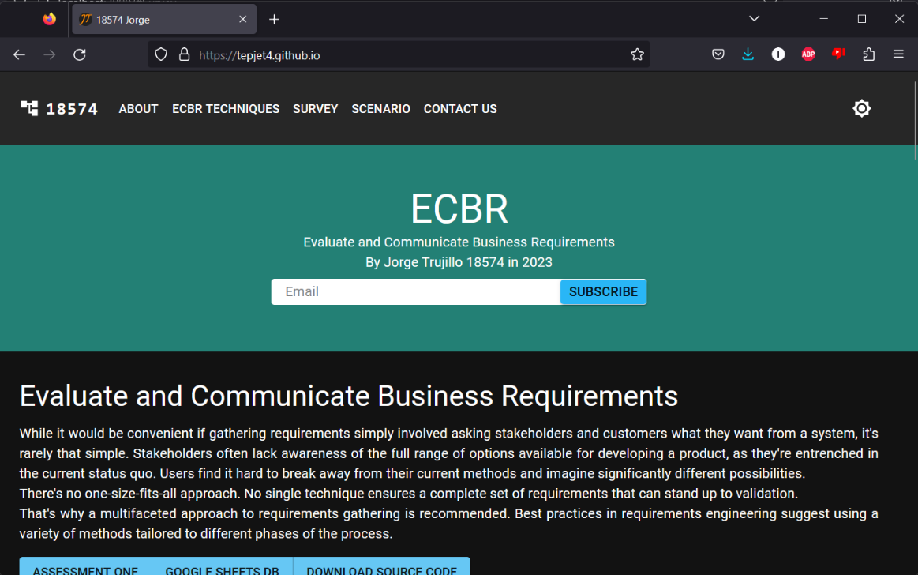

My web contact: [https://wellsjohn220.github.io/ecbr/#contact](https://wellsjohn220.github.io/ecbr/%23contact)

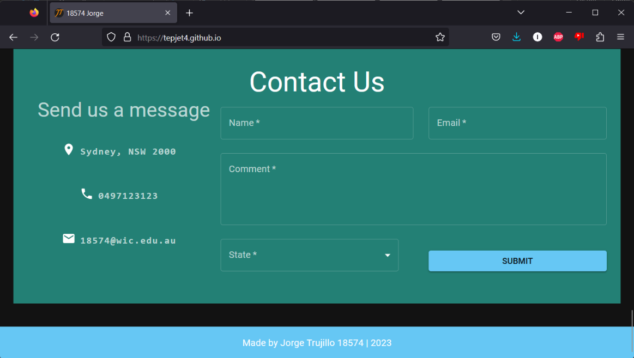

After inputting data, it will be stored:

It can be accessed at:

<https://docs.google.com/spreadsheets/d/1uGUl8t-9ZpIMKdeh_VGPLxTG_6Ni4g12aFkbx4kDGMo/edit#gid=597825602>

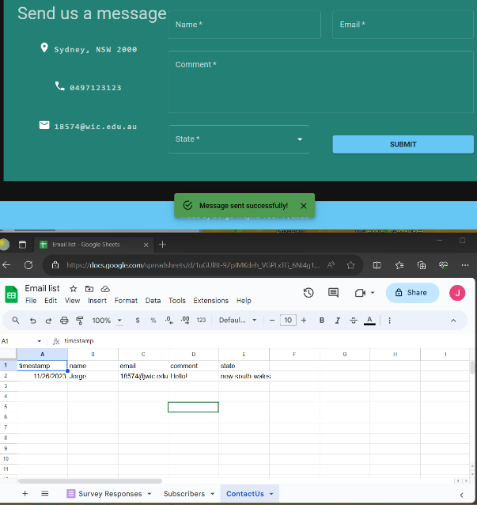

#### Task 2: Identify stakeholders

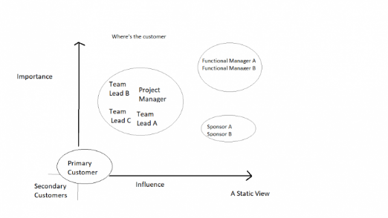 Identify stakeholders related in D&K Books system

All the staffs (the business owner, the relevant manager, the local workers and the remote workers) are stakeholders

Your comment: A company's employees, managers and board of directors make up a business's internal stakeholders. Employees of the company are invested in the company's performance to ensure they continue to be paid and retain their jobs.

#### Task 3: Develop support procedures

1. Describe one positive and one negative experience you have had when seeking assistance from a telecommunication company, an ISP or a computer supplier. Your experience may be via telephone, email or even voice recognition.

|  |  |  |
| --- | --- | --- |
| Type | Positive | Negative |
| Telephone | Immediate action. | Phone support time availability, wait time. |
| Email | Easy to attach any type of file, can be sent at any time. | Delayed action, uncertainty. |
| Go to company | Immediate action, best way to prove identity. | Transportation time and money, availability, wait time. |

1. Using the experiences described above please answer the following questions.
   1. What support aspects were professional and/or unprofessional? Every aspect has been professional in my experience.
   2. How long did the support process take? It’s varied, from a couple of minutes to several weeks trying to solve a simple access problem.
   3. Were the steps logical? Usually.
   4. Did they solve your problem? Despite multiple times trying, I couldn’t solve my problem.
   5. Was the call deflected to another area? No.

Using feedback form or Google survey form.

Here is the very simple survey demo:

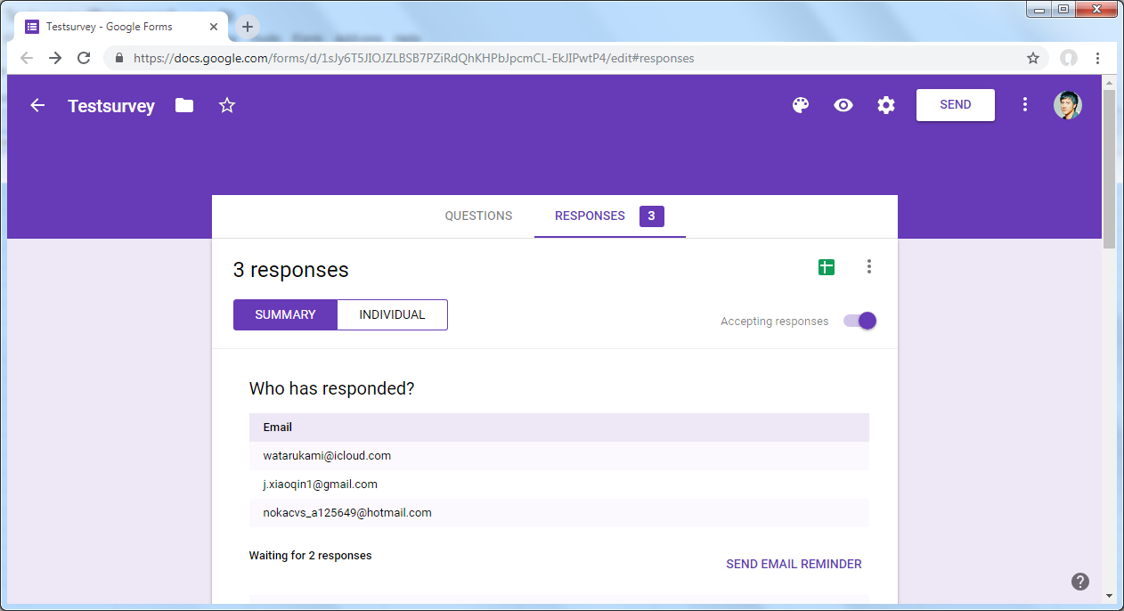

After I tested my friends, I could get nice response like:

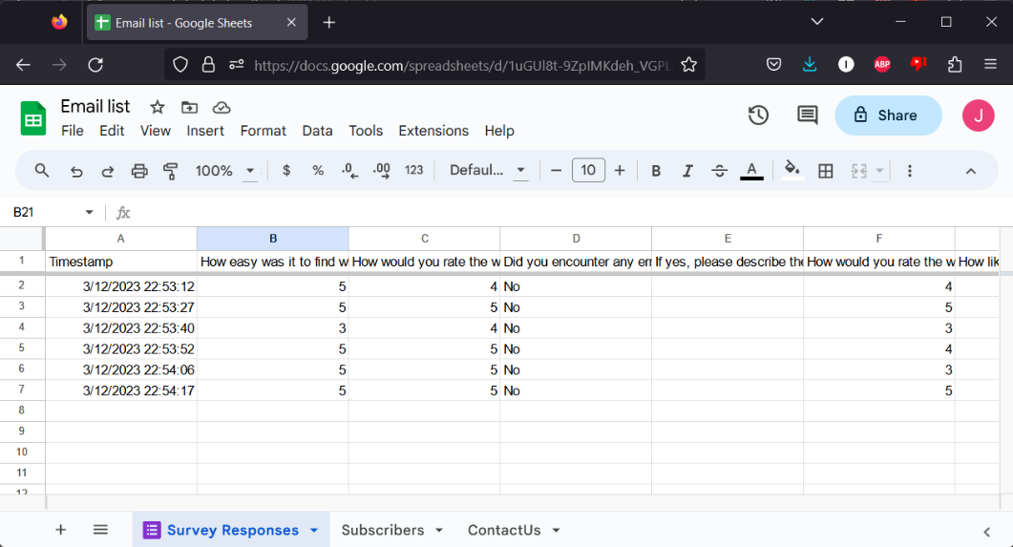

Or using link string:

<https://docs.google.com/spreadsheets/d/1uGUl8t-9ZpIMKdeh_VGPLxTG_6Ni4g12aFkbx4kDGMo/edit#gid=597825602>

Please review my website: [https://wellsjohn220.github.io/ecbr/#taskthree](https://tepjet4.github.io/#Survey)

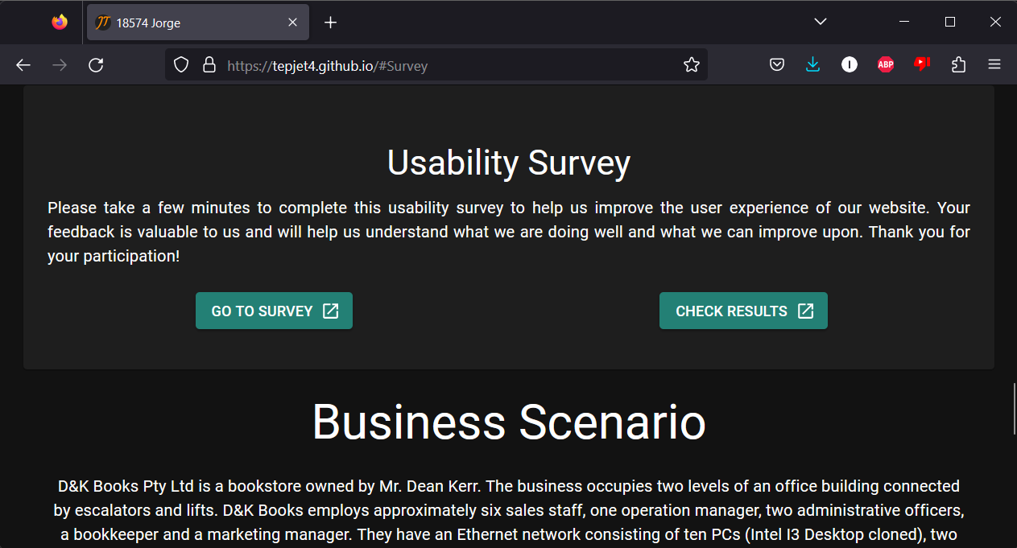

#### Task 4: Assign Support Personnel

Classify the following into soft skills and technical skills. Your answer should take the form of a table shown below.

|  |  |  |
| --- | --- | --- |
| **Skill** | **Soft skill** | **Technical skill** |
| A knowledge of Linux |  | X |
| The ability to work under pressure | X |  |
| The administration of Windows 2008 Server |  | X |
| The ability to formulate network and IT policies | X |  |
| The ability to write network documentation |  | X |
| The ability to give presentations | X |  |

#### Task 5: Short Answer Questions

1. 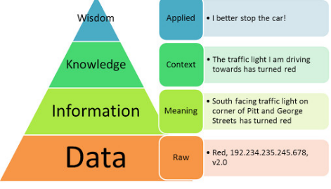Explain the relationship between data, information and knowledge.
2. What is quantitative data and how can you use it.
3. What is qualitative data and how can you use it.
4. 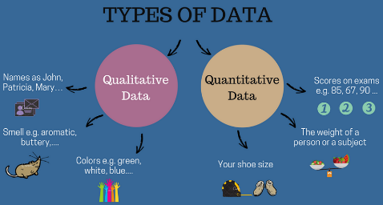Give an example of how quantitative and qualitative data can be used in conjunction with each other
5. What sort of methods could you use to determine client requirements for a website design and key information sources?
6. Give some examples of client requirements for a website design

* Looks good
* 24 hours work
* Easy to update
* Upgrade is free

#### Task 6: Multiple Choice Questions

1. 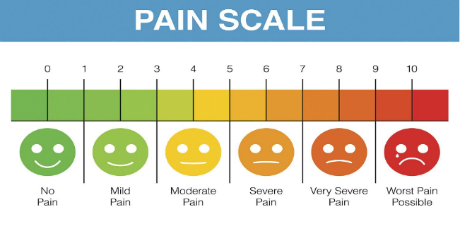Generally, how many points should a rating scale have?
   1. Five
   2. Four
   3. Ten
   4. Somewhere from 4 to 11 points Reason

Web refer: <https://lumoa.me/blog/rating-scale>

A rating scale is a closed-end survey question that is used to evaluate how survey responders feel about a particular product or statement.

Comment: I like 10 points. It is easy and clear to get the best feedback way.

1. What is the problem(s) with this set of response categories to the question “What is your current age?”

* 1-5
* 5-10
* 10-20
* 20-30
* 30-40
  1. The categories are not mutually exclusive
  2. The categories are not exhaustive
  3. Both a and b are problems Reason: limit ages are included twice
  4. There is no problem with the above set of response categories

1. You should mix methods in a way that provides complementary strengths and no overlapping weaknesses. This is known as the fundamental principle of mixed research.
   1. True
   2. False

Reason it provides the researcher with a logic for mixing quantitative and qualitative research approaches

1. According to the text, questionnaires can address events and characteristics taking place when?
   1. In the past (retrospective questions)
   2. In the present (current time questions)
   3. In the future (prospective questions)
   4. All of the above Reason
2. Which of the following are principles of questionnaire construction?
   1. Consider using multiple methods when measuring abstract constructs
   2. Use multiple items to measure abstract constructs
   3. Avoid double-barrelled questions
   4. All of the above
   5. Only b and c Reason
3. Which of these is not a method of data collection?
   1. Questionnaires
   2. Interviews
   3. Experiments Reason
   4. Observations
4. Secondary/existing data may include which of the following?
   1. Official documents
   2. Personal documents
   3. Archived research data
   4. All of the above Reason
5. An item that directs participants to different follow-up questions depending on their response is called a ____________.
   1. Response set
   2. Probe
   3. Semantic differential
   4. Contingency question Reason
6. Which of the following terms best describes data that were originally collected at an earlier time by a different person for a different purpose?
   1. Primary data
   2. Secondary data Reason
   3. Experimental data
   4. Field notes
7. Researchers use both open-ended and closed-ended questions to collect data. Which of the following statements is true?
   1. Open-ended questions directly provide quantitative data based on the researcher’s predetermined response categories
   2. Closed-ended questions provide quantitative data in the participant’s own words
   3. Open-ended questions provide qualitative data in the participant’s own words Reason
   4. Closed-ended questions directly provide qualitative data in the participants’ own words
8. Open-ended questions provide primarily ______ data.
   1. Confirmatory data
   2. Qualitative data Reason
   3. Predictive data
   4. None of the above
9. Which of the following is true concerning observation?
   1. It takes less time than self-report approaches
   2. It costs less money than self-report approaches
   3. It is often not possible to determine exactly why the people behave as they do Reason
   4. All of the above
10. Qualitative observation is usually done for exploratory purposes; it is also called ___________ observation.
    1. Structured
    2. Naturalistic Reason
    3. Complete
    4. Probed
11. When constructing a questionnaire, it is important to do each of the following except ______.
    1. Use "leading" or "loaded" questions Reason
    2. Use natural language
    3. Understand your research participants
    4. Pilot your test questionnaire
12. Another name for a Likert Scale is a(n):
    1. Interview protocol
    2. Event sampling
    3. Summated rating scale Reason
    4. Ranking
13. Which of the following is not one of the six major methods of data collection that are used by educational researchers?
    1. Observation
    2. Interviews
    3. Questionnaires
    4. Checklists Reason
14. The type of interview in which the specific topics are decided in advance but the sequence and wording can be modified during the interview is called:
    1. The interview guide approach Reason
    2. The informal conversational interview
    3. A closed quantitative interview
    4. The standardized open-ended interview
15. Which one of the following in not a major method of data collection:
    1. Questionnaires
    2. Interviews Reason
    3. Secondary data
    4. Focus groups
    5. All of the above are methods of data collection
16. A question during an interview such as “Why do you feel that way?” is known as a:
    1. Probe Reason
    2. Filter question
    3. Response
    4. Pilot
17. A census taker often collects data through which of the following?
    1. Standardized tests
    2. Interviews
    3. Secondary data
    4. Observations Reason
18. The researcher has secretly placed him or herself (as a member) in the group that is being studied. This researcher may be which of the following?
    1. A complete participant Reason
    2. An observer-as-participant
    3. A participant-as-observer
    4. None of the above
19. Which of the following is not a major method of data collection?
    1. Questionnaires
    2. Focus groups
    3. Correlational method Reason
    4. Secondary data
20. Which type of interview allows the questions to emerge from the immediate context or course of things?
    1. Interview guide approach
    2. Informal conversational interview Reason
    3. Closed quantitative interview
    4. Standardized open-ended interview
21. When conducting an interview, asking "Anything else?, What do you mean?, Why do you feel that way?," etc, are all forms of:
    1. Contingency questions
    2. Probes Reason
    3. Protocols
    4. Response categories
22. When constructing a questionnaire, there are 15 principles to which you should adhere. Which of the following is not one of those principles?
    1. Do not use "leading" or "loaded" questions
    2. Avoid double-barrelled questions
    3. Avoid double negatives
    4. Avoid using multiple items to measure a single construct Reason
23. A customer-based Service Level Agreement structure includes:
    1. An SLA covering all Customer groups and all the services they use
    2. SLAs for each service that are Customer-focused and written in business language
    3. An SLA for each service type, covering all those Customer groups that use that Service
    4. An SLA with each individual Customer group, covering all of the services they use Reason
24. Which of the following best describes the goal of Service Level Management?
    1. To maintain and improve IT service quality in line with business requirements Reason
    2. 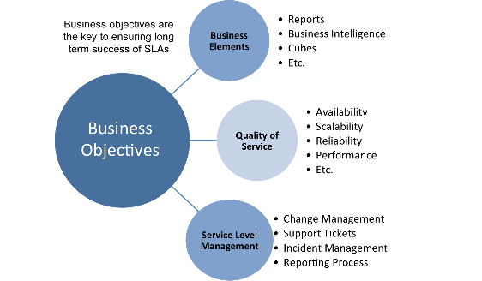To provide IT services at the lowest possible cost by agreeing with Customers their minimum requirements for service availability and ensuring performance does not exceed these targets
    3. To provide the highest possible level of service to Customers and continuously improve on this through ensuring all services operate at maximum availability
    4. To ensure that IT delivers the same standard of service at the least cost
25. The process to implement SLAs comprises of the following activities in sequence:
    1. Draft SLAs, catalogue services, review underpinning contracts and OLAs, draft SLRs, negotiate, agree SLAs
    2. Draft SLAs, review underpinning contracts and OLAs, negotiate, catalogue services,
    3. Review underpinning contracts and OLAs, draft SLAs, catalogue services, negotiate, agree SLAs
    4. Catalogue services, establish SLRs, review underpinning contracts and OLAs, negotiate service levels, agree SLAs Reason
26. Which of the following is an example of a service level agreement (SLA) between information systems support unit and a research unit in the laboratories of a large company?
    1. The maximum response time to get the system operational should it fail.
    2. The minimum ‘up-time’.
    3. The types of information that will be provided as standard.
    4. All of the above. Reason
27. Some organisations bring a degree of formality to the internal customer concept by encouraging (or requiring) different parts of the operation to agree on:
    1. Internal service agreements
    2. Service level agreements Reason
    3. Formal provision agreements
    4. Delivery agreements

## Index

B

bookstore 1

C

categories 6

closed-ended 7

D

data collection 9

L

Linux server 2

N

network 1

O

open-ended 7

S

Service Level 9

service level agreement 10

service quality 10

soft skills 5

support 3

T

technology 2

telecommunications 3